Self-Referral to Physiotherapy 

Please complete all sections of this form and return it to your GP Reception desk or your preferred Physiotherapy Department. Please ensure that your full name, full address and date of birth are on the top.
Please note – incomplete forms may not be processed.

Title | First Name (in full) | Surname
Date of Birth: |  | Today’s Date:
Address (including postcode):

Phone Number(s)  Home:  Mobile: |  | Consent to leave message including SMS text: YES NO (please circle)
Email address: |  | Do we have your consent to contact you via email? YES NO (please circle)
GP Name and Practice: |  | If required, do we have your consent to view your Medical Records? YES NO (please circle)
Where would you prefer to be seen? (please circle)
Copeland: Cleator Moor Egremont Seascale WCH
Allerdale: Cockermouth Keswick Maryport Wigton Workington
What is your appointment preference? (please circle)
Face to face Telephone Video call

- Please give a brief description of why you need a physiotherapy assessment (include area of body affected):__________
___________________________________________________________________________________________
__________________________________________________________________________________________

- How long have you had this problem? ___________________________________________________________

- Has this problem previously been treated with physiotherapy? Yes  No 

- Are the symptoms worsening? Yes  No 
(If yes, please give details)____________________________________________________________________________
___________________________________________________________________________________________

- Are you able to carry out normal activities? Yes  No 

- Are you off work/unable to care for a dependent because of this problem? Yes  No  Not applicable 

- Please give details of any other treatment you have received for these symptoms:_______________________________
___________________________________________________________________________________________

- Have you had any sudden weight loss without trying? Yes  No 

- Have you had any other symptoms such as numbness, tingling or muscle weakness which is either new or related to your current problem? Yes  No 
(If yes please give details)____________________________________________________________________________
____________________________________________________________________________________________________

- Have you had any recent changes to your bladder and bowel habits or altered sensation in the genital/saddle area Yes  No 
(If YES please see the information overleaf for advice and guidance).

- Please list any current or past medical conditions and bring the list to your first appointment i.e. heart conditions, high blood pressure, arthritis etc._________________________________________________________________________
____________________________________________________________________________________________________
- Please bring a list of your current medications to your first appointment.

Not sure if Physiotherapy is right for you?
Physiotherapy can be particularly beneficial if you are suffering from back pain, neck pain, recent injuries such as strains or sprains or joint and muscular pain. You can also see a physiotherapist if you are a man or woman suffering from incontinence. Unfortunately this service is not available if:
- You want to see a physiotherapist about a neurological or breathing problem
- You need a home visit
- You are under secondary school age (if you are under 16 you will need a guardian to accompany you to the assessment)
- If you want physiotherapy following a recent operation, for this you will need to be referred by your surgeon

Pain Relief?
Over the counter painkillers can be helpful. A pharmacist will be able to advise you on the appropriate tablets. If your symptoms worsen you may wish to see your GP. If you have an old injury, you may find that holding a hot water bottle wrapped in a towel on the affected area for 10 minutes reduces pain, while for a new injury you can use a pack of frozen peas wrapped in a damp towel for 10 minutes. Please be aware that hot and cold can burn and that you need to check every 5 minutes that your skin does not become very red or blotchy. If this happens, stop.

What can I do for myself in the meantime?
Research has shown that resting for more than a day or so does not help and may actually prolong pain and disability. You may need to modify your activities initially, but the sooner you can get back to normal activity the sooner you will feel better. Getting stiff joints and muscles working can be painful, but this is a normal response and not a sign of damage. Feeling a bit sore initially is also normal and often a good sign that you are making progress. Changing your position or activity frequently through the day will help to prevent and reduce stiffness. Try to build up your general activity gradually.

What happens next?
Complete the entire form (remember your name) and return it to your GP surgery. Once received your referral will be triaged by a physiotherapist and you will be contacted in due course to arrange an appointment. If you prefer you can email you completed form to ncm-tr.allerdalephysiotherapy@nhs.net (for Allerdale) or ncm-tr.copelandphysiotherapy@nhs.net (for Copeland).
Further Guidance from Question 10 overleaf
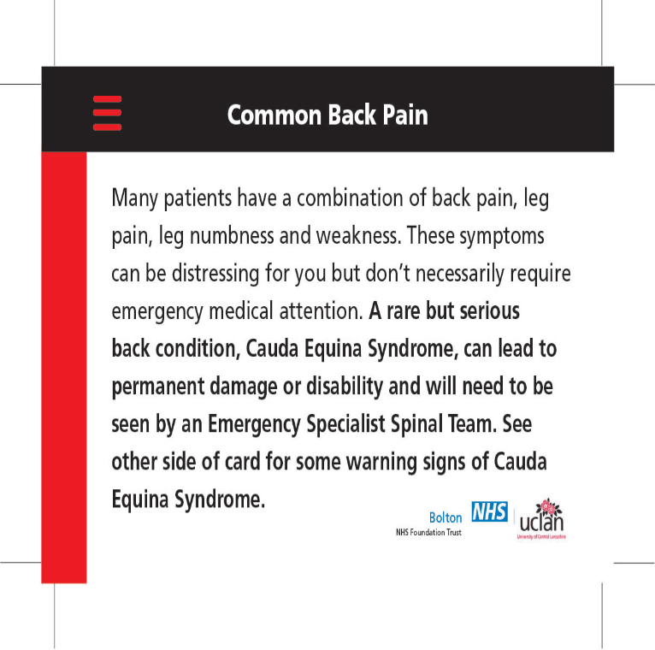
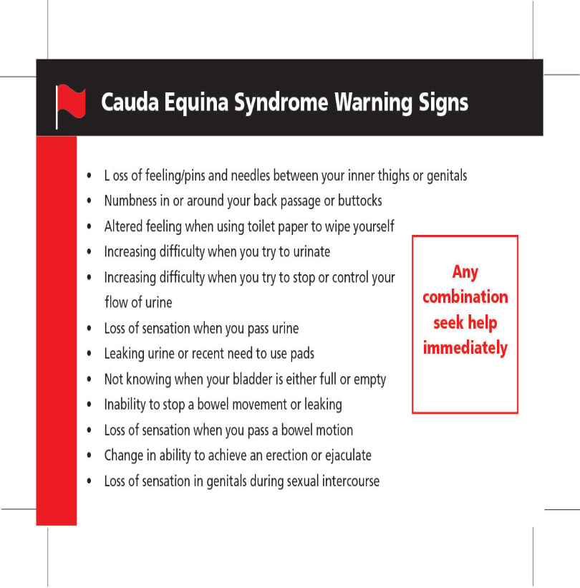

***If you are experiencing or develop the above symptoms it is advised you seek emergency medical advice through your GP practice, NHS 111 or the A and E department***

